Version Control
Version | Updated by | Dated | Purpose/Project Phase | Signature
1.0 | Rahul Zilpe | 18/10/2009 | Project – Testing Phase

Contribution
No. | Contributors
1
2
3
4

Distribution
Recipient | Date Issued | Signature | Comments/Remarks | Date
Project Team
Lim Siang Dat, Martin | 20/10/2009
Chetan Potnis | 20/10/2009
Ma Hong Yu | 20/10/2009
Rajendran Vinoth P | 20/10/2009
Soe Wai Lin | 20/10/2009
Khin Hnin Yee Aye | 20/10/2009
Ei Ei Thu | 20/10/2009
Rahul Zilpe | 20/10/2009
Fujitec Team
Mr. Raymond Khoo | 20/10/2009
Mr. Nandakumar | 20/10/2009
Ms. Tan Seow Hong | 20/10/2009

Related Documents
S/N | Filename | Description | File Location
1 | FCS/EPS /TURS | User Requirement Specification
2 | FCS/EPS /TFS | Use Case Realization Analysis Report

TABLE OF CONTENTS

Error! No table of contents entries found.

Enquire Purchase Order List and View Purchase Order Details
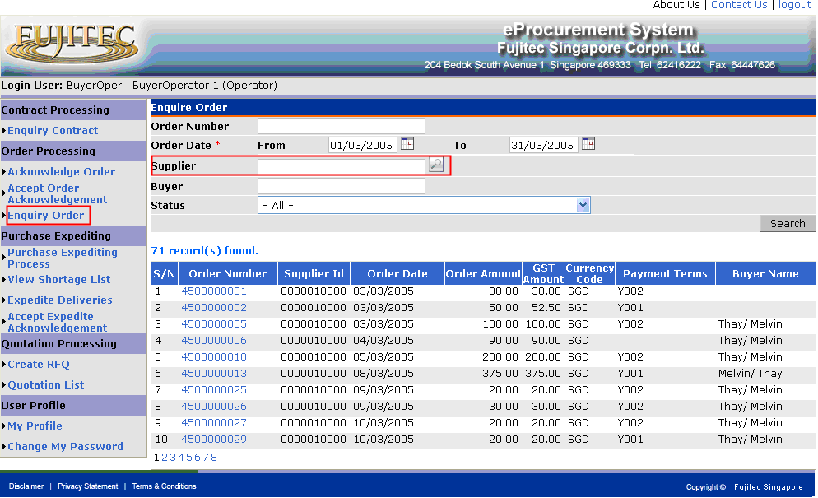
Fig : “Enquire Order List”

This function is applicable for Suppliers and Buyers. If the login user is Supplier, the Supplier search criteria will be disabled. It means Suppliers only can enquiry their own orders.

- Click “Enquiry Order” from left pane of screen.

- Select search criteria (if any), and then press Search button. The orders which meet selected search criteria will be displayed.

- Click Order Number hyperlink from the order list. The Purchase Order Details will be displayed as shown in below figure (Fig : “Purchase Order Details”).
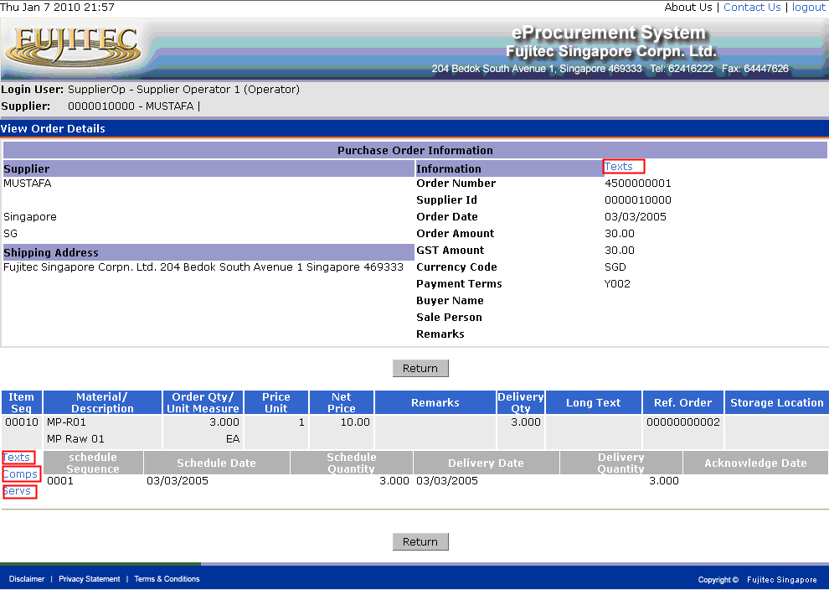
Fig : “Purchase Order Details”

- Click Texts hyperlink in the purchase header, the Purchase Header Texts will be displayed as shown in below figure (Fig : “Purchase Order Header Text”).

- Click Texts hyperlink in the purchase line item, the Purchase Item Texts will be displayed as shown in below figure (Fig : “Purchase Order Item Text”).

- Click Comps hyperlink in the purchase line item, the Purchase Order Subcontractor Components will be displayed as shown in below figure (Fig : “Purchase Order Subcontractor Component”).

- Click Servs hyperlink in the purchase line item, the Purchase Order Service Items will be displayed as shown in below figure (Fig : “Purchase Order Service Item”).

- Click Return button go back to Enquiry Order List

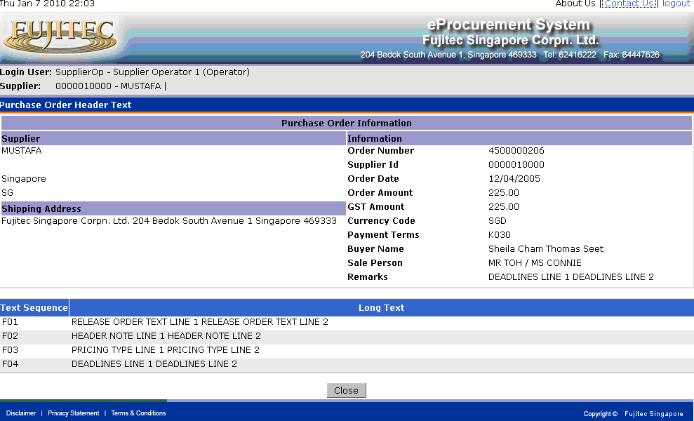
Fig : “Purchase Order Header Text”

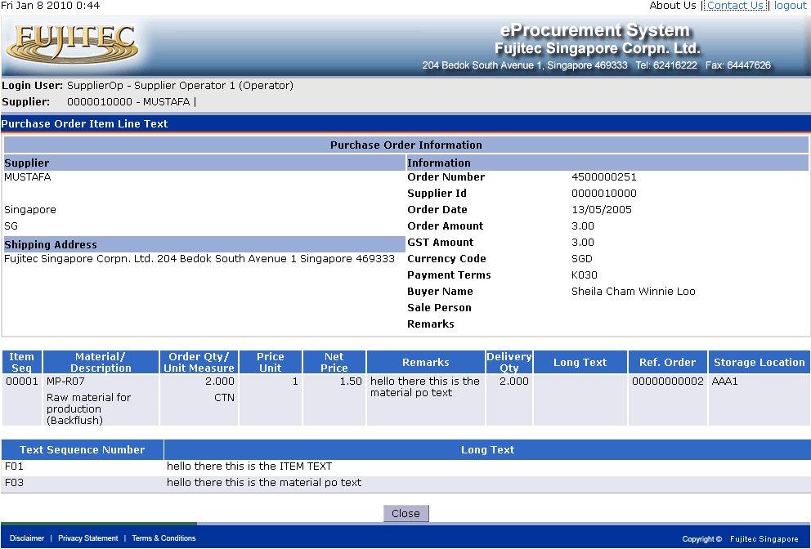
Fig : “Purchase Order Item Text”
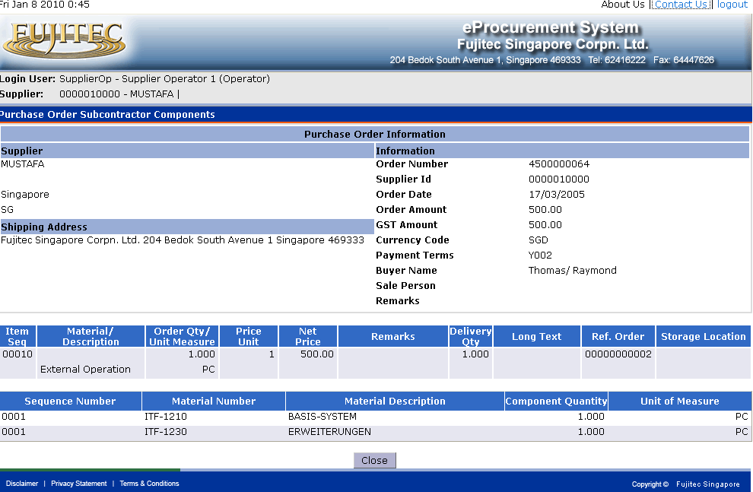
Fig : “Purchase Order Subcontractor Component”

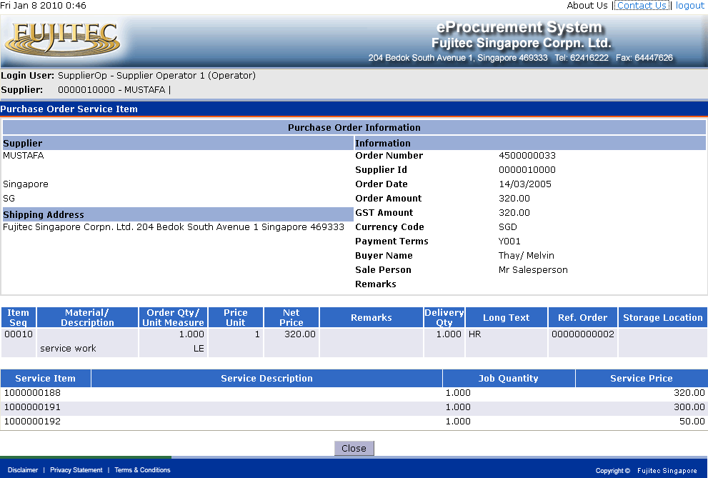
Fig : “Purchase Order Service Item”

Enquire Purchase Contract List and View Purchase Contract Details
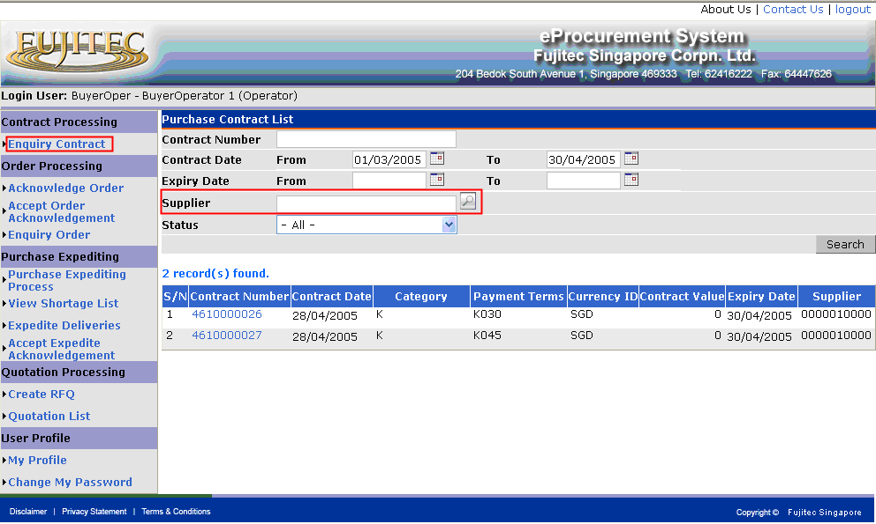
Fig : “Enquire Purchase Contract List”

This function is applicable for Suppliers and Buyers. If the login user is Supplier, the Supplier search criteria will be disabled. It means Suppliers only can enquiry their own purchase contracts.

- Click “Enquiry Contract” from left pane of screen.

- Select search criteria (if any), and then press Search button. The purchase contracts which meet selected search criteria will be displayed.

- Click Contract Number hyperlink from the contract list. The Purchase Contract Details will be displayed as shown in below figure (Fig : “Purchase Contract Details”).
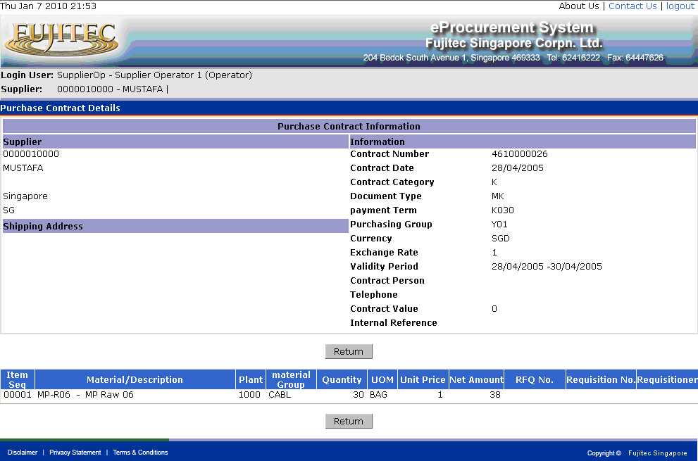
Fig : “Purchase Contract Details”

- Click Return button go back to Enquiry Purchase Contract List

Purchase Order Expediting
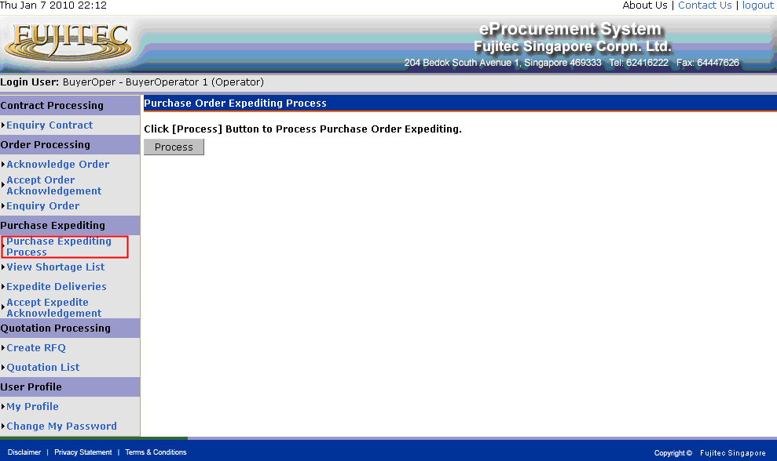
Fig : “Purchase Order Expediting Process”

This function is applicable for Buyers.

- Click “Purchase Expediting Process” from left pane of screen. .

- Click Process button to start processing. The below message will be display, when processing is completed.

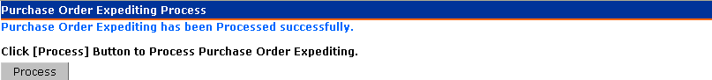

View Shortage List
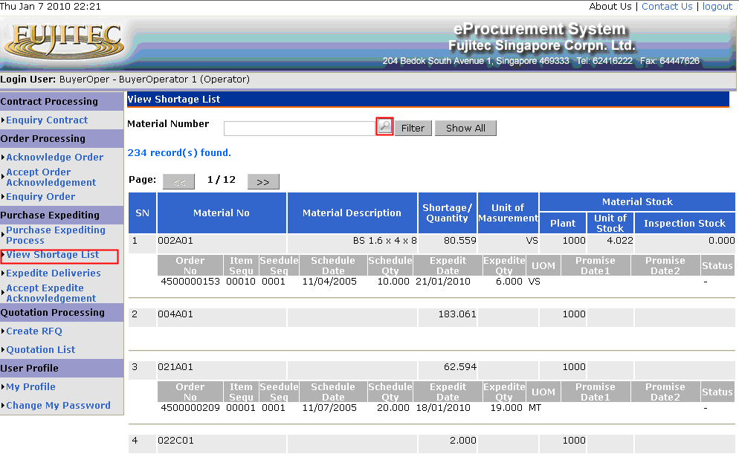
Fig : “View Shortage List”

This function is applicable for Buyers.

- Click “View Shortage List” from left pane of screen. .

- The function allows users to filter by particular Material. Upon Clicking button, the Material Search Dialog will be displayed as shown in below figure (Fig : “Material Search Dialog”). After selected the material form Material Search Dialog, and then click Filter button, the related shortage material will be displayed.

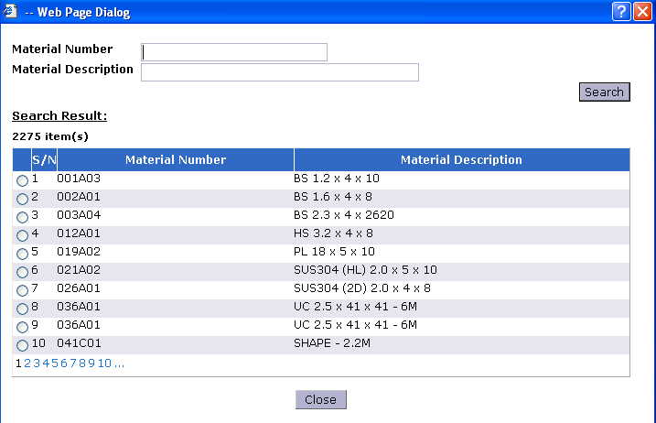
Fig : “Material Search Dialog”

